Yelp Feedback Data Analysis

Gayathri Ganesh  
(013804674)  
[gayathri.ganesh@sjsu.edu](mailto:gayathri.ganesh@sjsu.edu)

Prachi Jani  
(013801359)  
[prachi.jani@sjsu.edu](mailto:prachi.jani@sjsu.edu)Priya Chaitanya Yadav  
(013836719)  
[priyachaitanya.yadav@sjsu.edu](mailto:priyachaitanya.yadav@sjsu.edu)

Harshitha Yerraguntla  
(013800280)  
[harshitha.yerraguntla@gmail.com](mailto:harshitha.yerraguntla@gmail.com)Rama Tejaswini Thotapalli  
(013785681)  
[ramatejaswini.thotapalli@sjsu.edu](mailto:ramatejaswini.thotapalli@sjsu.edu)

# Introduction

Yelp is a web service that offers a rich set of crowdsourced reviews about local businesses and online reservations. Every business is dependent on customer satisfaction. User reviews are an essential part of the review websites like Amazon and Yelp. Users can post their reviews about businesses, products, and services. Typically, Reviews can be a free-form text and a numeric star rating. These online reviews are standard for consumers to choose between related products. Researches show that reviews have a significant impact on business revenue, consumer purchase decisions and product sales. Yelp allows users to post online reviews for various businesses, products, and services. It has been shown recently that user reviews have a notable influence on consumer shopping behavior. Review Rating Prediction predicts a user’s star rating for a product based on the user’s text review for the product. It has become a familiar problem in machine learning. Sentiment Analysis, a subset of machine learning is very important for any business**.** From the user reviews, business owners can easily discover out which features of the business they need to improve.

Keywords—component, formatting, style, styling, insert (key words)

# Data Collection

Data has been collected from a subset of Yelp’s businesses, reviews, and user data. It was taken from the Yelp Dataset Challenge provided for the students for research and analysis. Businesses across 11 metropolitan areas in four countries are provided in the dataset. Yelp dataset has different businesses that belong to different categories, such as, shopping, hotels, travel, and restaurants, etc. The text reviews for different business categories may be very different. Dataset consists of five files which consist of one JSON object per line. Business, review, user, check-in, and tip are the five files in the dataset. Business.json specifies business details such as business id, name, location data, attributes, review count, star rating and working hours. Review.json specifies review id, user id, business, star rating, date, review text, and votes. user.json specifies user information, a number of reviews written, a list of the user's friends and all the metadata associated with the user. Checkin.json specifies check-ins on a business. Tips are reviews shorter than reviews which convey quick suggestions. Tip.json specifies tips written by a user on a business. Most of the important data required to build a predictive model exist in business.json and review.json files.

## Dataset Information

5,200,000 user reviews.

Information on 174,000 businesses

The data spans 11 metropolitan areas

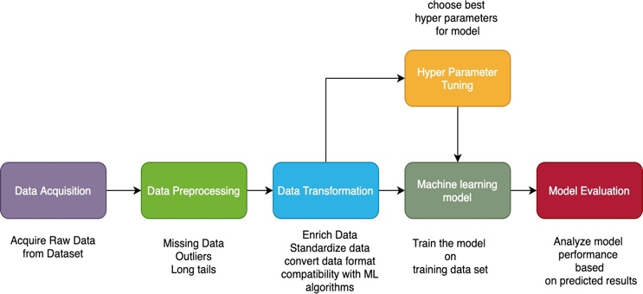

# Fig.1 Model Development

# Data Preprocessing

It is a technology for data mining that makes raw data understandable. Raw information (real- world information) is often incomplete and cannot be sent through a model. This will lead to some errors. Therefore, before we submit a model, we have to prepare the details.

## Data Preprocessing Steps

* Missing values are checked
* Checking for Categorical Data
* Data Cleaning
* Feature Extraction

## Checking for missing values

Let’s look at the data.

The dataset is labeled with business_id.

hasValue or 1 = non fraud

hasValue.IsEmpty or 0 = fraud

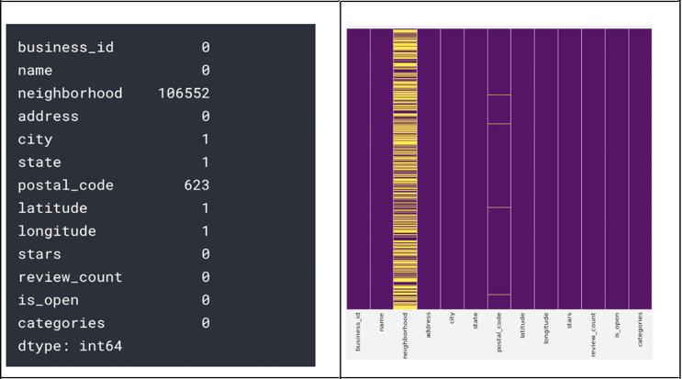

## Checking for Categorical

Let's handle and change the dtype for each column to the corresponding type. First we define a function to construct the distribution plot of various variables. The initial distribution of characteristics is present here.

As main libraries, I am using Pandas, Numpy and time;

**Pandas**: Use for data manipulation and data analysis.

**Numpy**: a fundamental package for scientific computing with Python.

In [1]

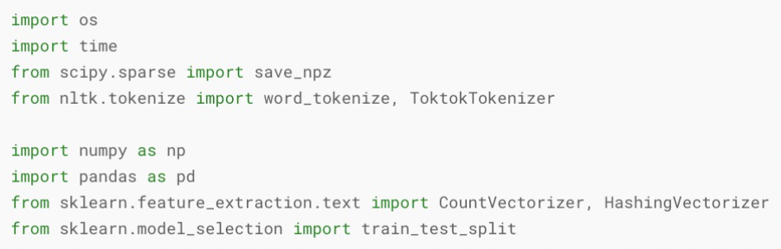

In [2]

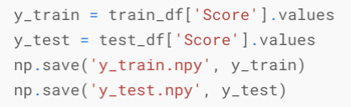

In [3]

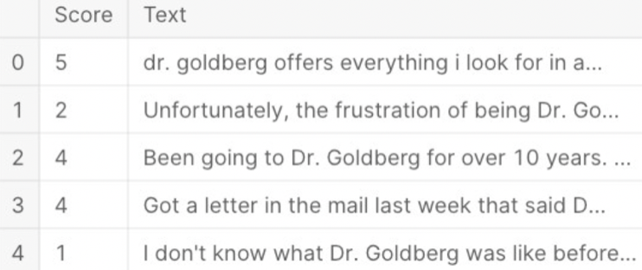

In [4]

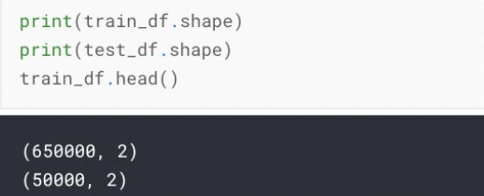

Out [4]



Save Target:

In [5]



## Checking for Categorical

In the United States, we kept just company knowledge from 6 states. Because we just know for restaurants, we have been filtering in the company data collection for all other forms of companies. We have also found that there is not much useful review details in the closed restaurants, so we have excluded restaurants that are not open with the "is open" column. In order to eliminate all the input unrelated to the restaurants we cleaned, we matched business ids with cleaned business data in the company as well as review data sets. In addition, the analysis and company databases have been cleaned up.

## Feature Extraction

We use four methods to extract the useful characteristics of the analysis corpus and to construct an evaluation vector. Growing approach depends on semantical text analysis.

## BOW

In [6]

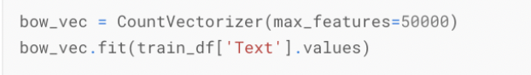

Out [6]

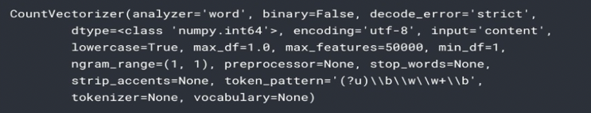

In [7]

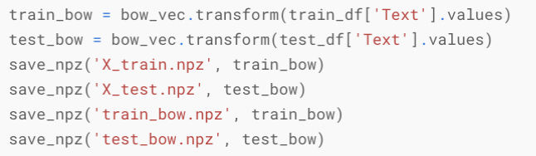

## Bi-Grams

In [8]

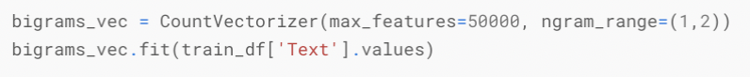

Out [8]

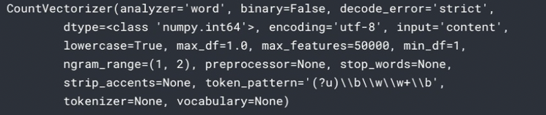

In [9]

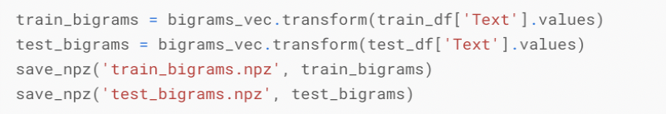

## 4.3 Tri-Grams

In [10]

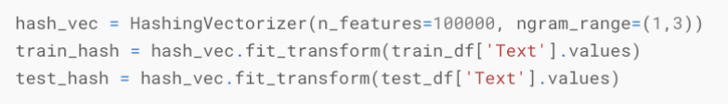

In [11]

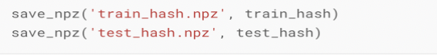

## 4.4 Fast Text

In [12]

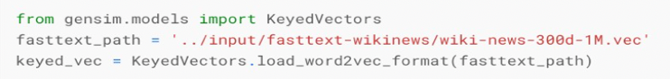

In [13]

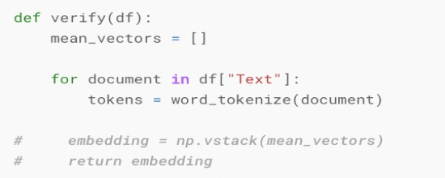

In [14]

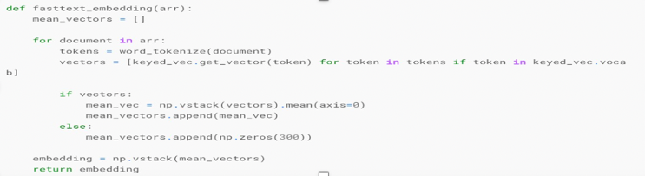

In [15]

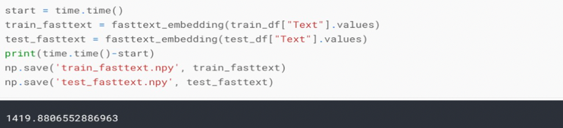

# Exploratory Data Analysis

Exploratory Data Analysis will provide visualization and transformation of data in a way that it shows the main insights from the data. It is an iterative cycle which

1. Generates questions about data.
2. Provides answers to the questions by visualizing and modeling.
3. Use the modeled data to predict/forecast or to generate new questions

EDA is a key part of Data analysis that cleans, transforms, draws insights and investigates the quality of data. Some of the Exploratory Data Analysis performed on the Yelp data are below

Data Information

The below figure will provide the description of the dataset and the number of observations and attributes in the dataset.

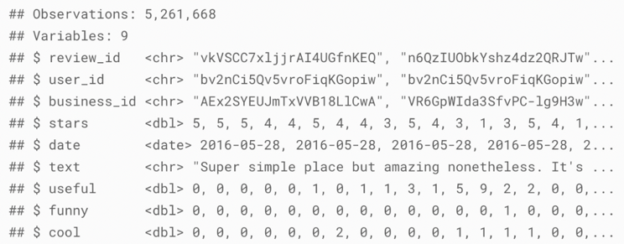

Missing Values in the Data

Below are some of the missing values in a few of the attributes.

From the below figures the neighborhood column contains 106552 null values and the postal code column contains 623 null values.

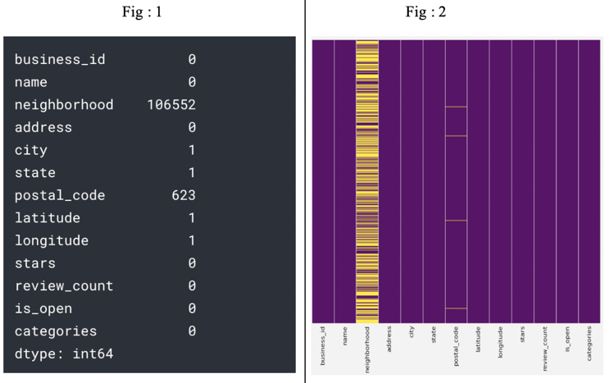

From figure 3 we can say that number of businesses open and the number of businesses not open

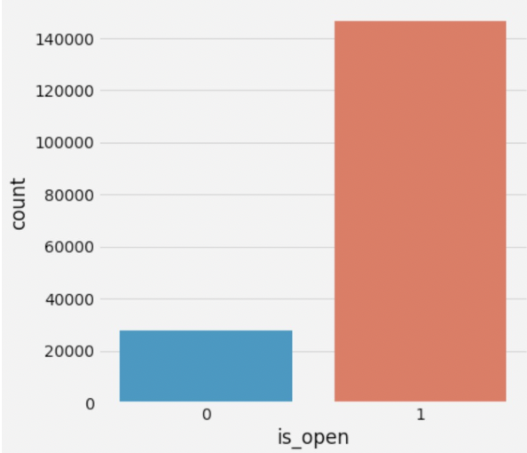

Figure 4 depicts the frequency of rating and Normal distribution plot of the businesses. Most of the businesses fall under rating 4.

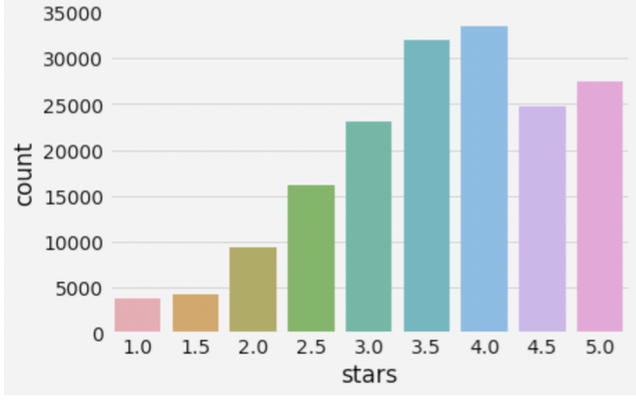

The below figure represents the common business in states count reviews for which we have analyzed the data.

The below figure shows the number of businesses in which category. Restaurants are the highest business in yelp.

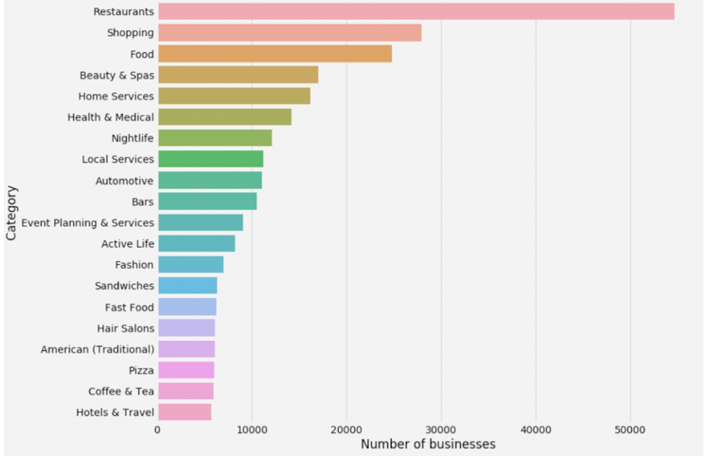

Below is the word cloud of the yelp business name column of the Yelp dataset.

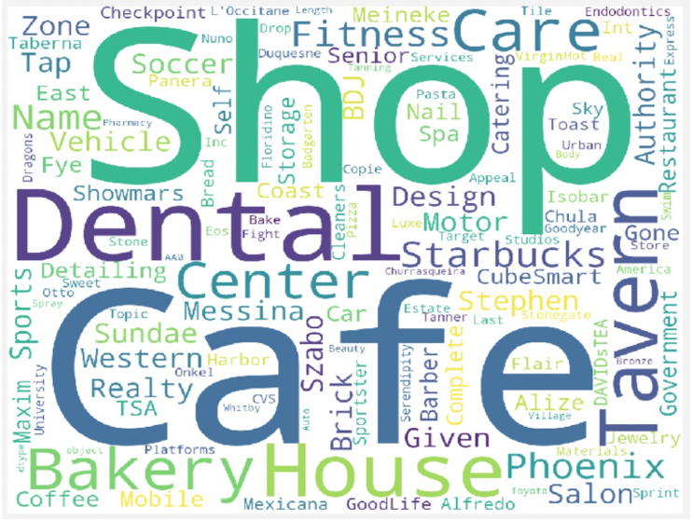

Following figure is geographical business strip view of Las Vegas state

**Figure: Business Strip View**

# A screenshot of a cell phone Description automatically generatedSystem Architecture

Algorithm:

1. Collect the yelp feedback data from a legal website/ live feedback data.
2. Perform preprocessing of data to scale and normalize the data.
3. Visualizing the data to know the outliers present.
4. Import collected data into the Cassandra database using R studio.
5. Perform data analytics using R to gain more insights into the data.
6. Visualize the data to present the learned insights.
7. Integrate visualizations to the user interface.
8. Provide the recommendations to the end-users/clients using the analytics.

# SOA Architecture



***Figure: SOA Architecture***

Identification

In identification we will identify the important attributes in our dataset.

In this process we will follow the below services in order to analyze the patterns in the data.

1. Cleaning services
2. Preprocess data services
3. Integration services (Mapping required fields)
4. Analyze
5. Visualize
6. Deploy

**Specification**

Below the services we are going to use for different operations,

1. We will use the service to pull the yelp feedback data.
2. Data Preprocessing
3. Data Cleaning and Exploration.
4. Import collected data into the Cassandra database.
5. Integrate Cassandra with R Studio.
6. Analyze the data using R
7. Visualize the data to gain insights.
8. Integrate visualizations to the user interface.

**Realization**

In this step, we are designing and implementing the services that are important for Yelp Feedback Analysis. We are realizing our project using :-

1. R/Python APIs to handle Data Cleansing (As part of Data pre-processing step).
2. Cassandra DB as our Backend database.
3. Python and R as our programming language.
4. Visualization component using R.
5. User Interface Component (Dashboards to help users - specialists).
6. Tableau for Data visualizations.

# **Dependancies and chanllenges**

For this project, we overcame a few challenges which involved with Data Preprocessing step

1. Data cleansing - Converting NULL values into NaN / replacing them with Mean values for Numeric columns
2. Installing the necessary libraries and their dependencies
3. Loading/Extracting Data from Cassandra DB

# **Tools and Technologies**

For this project, we have used the following Tools and Technologies:-

* Data Cleaning & Pre-processing: NumPy and Pandas libraries.
* Programming Language(s): R Studio 3.6.3 & Python 3.7x
* Database : Cassandra DB
* Data Visualization : R Studio 3.6.3,Tableau

# **Dashboard and Topic Modeling**

This Project was about putting together a Yelp dataset. This dataset is a subset of Yelp Dataset Challenge where we had an opportunity to conduct research and analysis on Yelp’s data and share their discoveries. In the dataset we found information about businesses across 11 metropolitan areas in four countries.

**Figure: Glimpse of our Dashboard**

For a city we spotted the most popular business and also provided a map of the city of Las Vegas with the business identified as dots in the map. We analyzed Las Vegas , Toronto and Phoenix. For Phoenix city, we also do Word Cloud, detailed Sentiment Analysis and Topic Modelling.

**We performed sentiment analysis for the businesses**

How can this help businesses?

If the business owners can just see the Top Ten negative reviews, they can easily find out which aspect of the business they need to improve.

**Figure: Sentiment Analysis Bacchanal Buffet**

**Figure: Sentiment Analysis Chipotle**

We performed Topic modelling.

How Topic Modelling can help understand the business and city ?

Topic modelling helps to pick specific topics from the huge volume of text. Topic Modelling on the two popular restaurants and also on Phoenix City helped us to understand that complaints regarding restaurants and business are around Services.

**Figure: Topic Modeling MonAmiGabi**

**Figure: Topic Modeling Bacchanal Buffet**

**Figure: Topic Modeling Phoenix City**

# References

[1] https://www.kaggle.com/ambarish/a-very-extensive-data-analysis-of-yelp.

[2] https://medium.com/@urytrayudu1/sentiment-analysis-for-yelp-review-classification-54b65c09ff7b

[3] https://medium.com/swlh/sentiment-analysis-of-online-reviews-ee2b461f7dec

[4] https://medium.com/swlh/sentiment-analysis-of-online-reviews-ee2b461f7dec

 Prachi Jani

 Gayathri Ganesh

 Priya Chaitanya Yadav

 Rama Tejaswini Thotapalli

 Harshitha Yerraguntla